Checks and Questions ISATPhone-FleetPhone

Questions
- What is your mobile’s ICCID or MSISDN?
- What is the software version used (Inmarsat Firmware and device Firmware)?
- In which country or region are you located?
- Is your antenna signal strong and stable? How many bars are there?
- Did the terminal work before?
- Since when did the service stop working?
- What is the error code or error message on the screen or during connection to data/SkyFile?
- Is the current GPS Position up-to-date?
- If a red planet is displayed on the screen, it means that the GPS position is not valid and that the phone is still searching.
- For FleetPhone only: What is the terminal manufacturer and model (Oceana 400, Oceana 800, terra 800)?
  - For the phone’s firmware, it is found in Settings > About.
- Are you using a username and password for the connection? If yes, please confirm.
- The username and password is the same, “INMARSAT” (all in upper case).
- If a docking station is used: Please advise the model and Firmware of the docking station.
  - Firmware can be found in the About section of the software, given by the manufacturer of the docking (Mainly Beam systems).
- Please advise if the handset used is a Marlink one.

Checks
- Software info:
  - In case the IsatPhone software version is on the Inmarsat website: www.inmarsat.com/support.
  - In case of FleetPhone or DS, the customer needs to use a tool called Falcon, which is available at www.beamcommunications.com.
- Check the card status in BSS, The Source.
- Check call records in The Source.
- Check the GPS position with the customer.
- Check the antenna signal with the customer.
- In case of any SkyFile issue with IsatPhone/ FleetPhone:
  - If possible, for SkyFile communications, advise if a modem is directly used or if they are using the port com.
  - In the Device Manager, check the status of the com port related to the IsatPhone (Can you see a yellow question mark (?) or not?).
  - The Device Manager is the screen where all the ports are referenced. To go there, you need to right-click on the Computer icon, then click on ‘Manage’ and finally ‘Device manager.’
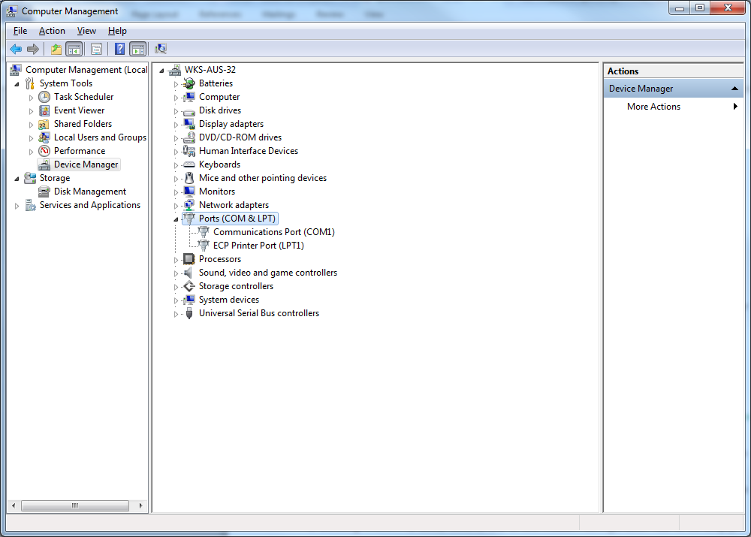
  - If also possible, check if the AT command (“AT&FE0&D2”) is implemented in the modem configuration (Data only).
- How/where exactly can this be checked?
- Go to Control Panel > Phones and Modem.
- Then, for the modem part, select Isatphone Pro1.0 Modem, then click on ‘Properties,’ and in the Advance Menu, check for the line “Extra Initialization commands.”
- For SkyFile use and if no docking station is used, check the AT command in the second line of the modem option.
- How/where exactly can this be checked?
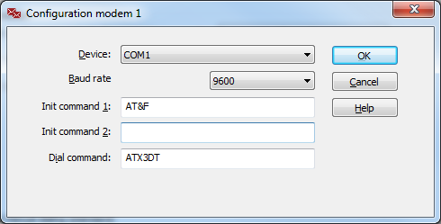
In the SkyFile account and dial parameters in the modem options as shown below:

- If the docking station is used, the second line of the modem configuration has to be empty.

